SIMATS ENGINEERING
ASSESSMENT TOOL 2
COURSE NAME: INTERNET PROGRAMMING
COURSE CODE: CSA43
COURSE OUTCOME COVERED
CO-1: Develop well-structured, standards-compliant web pages using HTML/XHTML and XML, and apply Internet protocols and HTTP communication mechanisms for web content delivery. (L2)
Assessment Tool : Data Interpretation
Weightage: 20%
QUESTIONS: Total Marks: 20

1: HTTP Response Analysis
A web server returns the following HTTP response header:
HTTP/1.1 200 OK
Date: Mon, 01 Apr 2026 10:00:00 GMT
Content-Type: text/html
Content-Length: -150
Connection: keep-alive Questions:
- Identify any incorrect or invalid fields in the header.
- Analyze the issue with Content-Length and explain its impact.
- Determine whether the status code matches the response correctness.
- Suggest corrections for the identified errors.

2: DOM Structure Analysis
Consider the following DOM tree representation:
<html>
<head>
<title>Test Page</title>
</head>
<body>
<div>
<p>Hello World
</div>
</body>
</html>
Questions:
- Identify missing or improperly closed elements.
- Analyze how the browser will interpret this structure.
- Determine the impact on rendering and layout.
- Suggest corrections to make the DOM valid.

3: GET vs POST in Login System
A login system uses two different methods:
Method URL Example Data Visibility Security Level
GET /login?user=admin&pass=1234 Visible in URL Low
POST /login Hidden in body Moderate
Questions:
- Interpret the differences in data transmission between GET and POST.
- Analyze which method is more suitable for login and why.
- Identify security risks in using GET for authentication.
- Suggest best practices for secure login implementation.

4: HTML Code Inspection
Analyze the following HTML snippet:
<!DOCTYPE html>
<html>
<head>
<title>Sample</title>
</head>
<body>
<h1>Welcome
<p>This is a paragraph
<img src="image.jpg">
</body>
</html>
Questions:
- Identify missing closing tags.
- Analyze issues with the <img> tag.
- Determine how browsers will handle these errors.
- Suggest a corrected version of the code.

5: Browser-Server Communication Flow
The following sequence describes a web request:
- User enters a URL in the browser
- DNS lookup occurs
- HTTP request is sent
- Server processes request
- Response is returned
- Browser renders page
Questions:
- Interpret each step in the communication flow.
- Identify where delays can occur.
- Analyze the role of DNS in the process.
- Suggest optimizations to improve performance.

Code of Conduct:
I _R.Asif(192411163)_ (Name / Reg No) certify that this submission is my original work and that I have adhered to the guidelines specified for this assessment. I understand that any violation of academic integrity rules will result in disciplinary action.
Signature of the student: R.Asif
RUBRICS FOR CALCULATION:
Criteria | Weightage | Level 4 (Exemplary) | Level 3 (Proficient) | Level 2 (Developing) | Level 1 (Beginning)
Understanding of Data | 25% | Accurately interprets all data patterns, trends, and relationships | Interprets data correctly with minor  gaps | Partial understanding; misses key trends | Misinterprets or fails to  understand data
Analysis | 25% | Provides deep analysis with strong logical  reasoning and justification | Provides reasonable analysis with some justification | Basic analysis with weak reasoning | No meaningful analysis provided
Application of Concepts | 20% | Effectively applies relevant concepts/tools to interpret data accurately | Applies concepts with minor errors | Limited application; requires guidance | Unable to apply  concepts to data
Conclusion | 20% | Draws clear, meaningful  conclusions with strong insights and implications | Provides valid conclusions with moderate insights | Conclusions are vague or weak | No clear or valid conclusions
Clarity | 10% | Presents interpretation | Generally clear with | Lacks clarity or | Poor

 |  | clearly using proper  structure, visuals, and terminology | minor issues | proper structure | presentation  and difficult to understand

Answers

Question 1: Identify the errors
Given HTTP response:
HTTP/1.1 200 OK
Date: Mon, 01 Apr 2026 10:00:00 GMT
Content-Type: text/html
Content-Length: -150
Connection: keep-alive

Explanation
- HTTP/1.1 200 OK — indicates that the request succeeded, but it does not guarantee that every response header is valid.
- Date — the date format is recognizable, although the weekday and calendar date should be checked for consistency.
- Content-Type: text/html — identifies the response body as HTML.
- Content-Length: -150 — invalid, because content length must be a non-negative decimal integer.
- Connection: keep-alive — requests that the connection remain open for reuse.

Corrected response
HTTP/1.1 200 OK
Date: Wed, 01 Apr 2026 10:00:00 GMT
Content-Type: text/html
Content-Length: 44
Connection: keep-alive

<html><body><h1>Hello</h1></body></html>
The body shown above is 38 bytes in ASCII, not 44. Therefore, the exact corrected header for that body is:
Content-Length: 38
The server must calculate the actual byte length of the body it sends. The HTTP status can remain 200 OK if the request succeeds and the response is valid.
Screenshort:
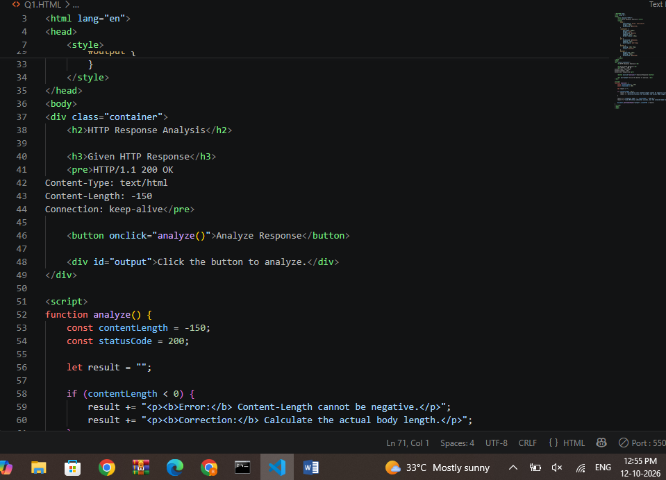
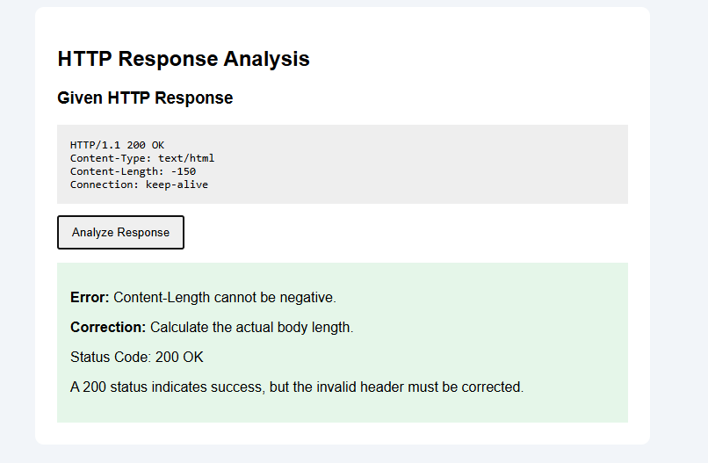

2. DOM Structure Analysis
Problem: The paragraph element is not properly closed.
Original code:
<html>
<head>
<title>Test Page</title>
</head>
<body>
<div>
<p>Hello World
</div>
</body>
</html>

Correct code
Create a file named dom.html and paste this code:

<!DOCTYPE html>
<html lang="en">
<head>
<meta charset="UTF-8">
<title>Test Page</title>
</head>
<body>
<div>
<p>Hello World</p>
</div>
</body>
</html>

Explanation
- The <p> element is explicitly closed using </p>.
- The <div> element contains the paragraph.
- The browser creates a DOM tree from the HTML.
- Browsers automatically repair many common HTML errors, but valid markup is recommended.
Expected output:
BROWSER OUTPUT
Hello World
Screenshort:
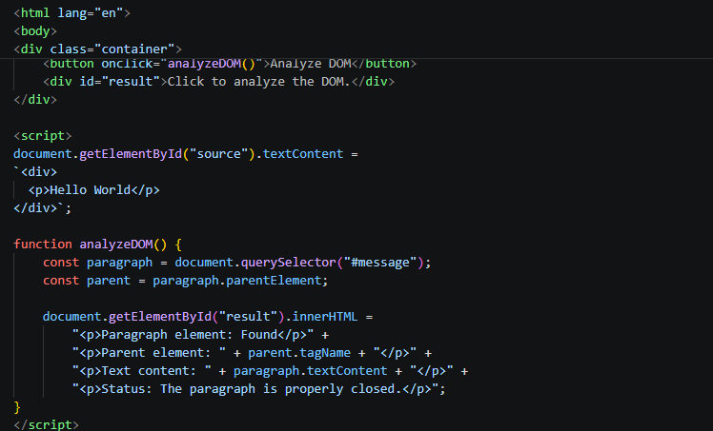
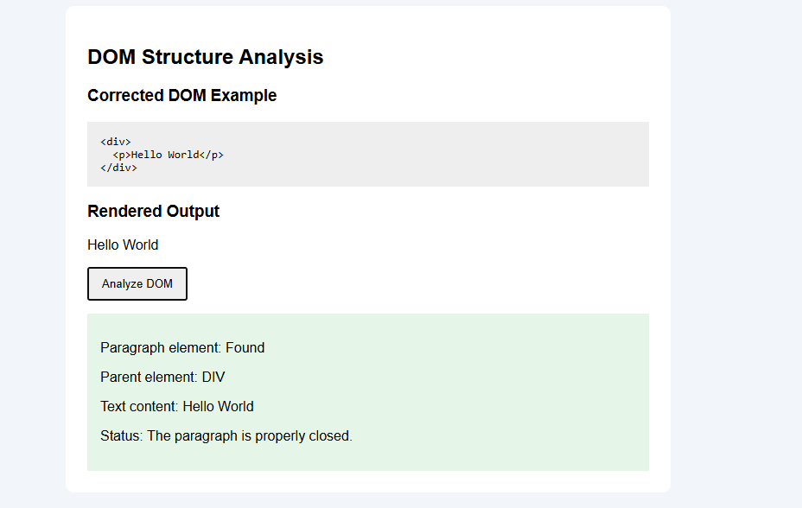

3. GET vs POST in a Login System
Feature | GET | POST
Data location | URL query string | Request body
URL visibility | Data may appear in URL | Data normally isn't in URL
Browser history | Query may be recorded | Body isn't normally recorded in history
Login suitability | Avoid for passwords | Preferred for submitting credentials
Encryption | Requires HTTPS for encryption | Also requires HTTPS for encryption

Explanation
GET is mainly used to retrieve resources. For example:
GET /login?user=admin&pass=1234
This exposes credentials in the URL, where they may be saved in logs, history, or other records.
POST sends the submitted form data in the request body:
POST /login
Content-Type: application/x-www-form-urlencoded

username=admin&password=example
POST does not automatically make a request secure. Use HTTPS, hash passwords on the server, protect session cookies, validate inputs, and apply rate limiting.
For this question, the correct recommendation is to use POST over HTTPS for login credentials.
Screenshort:
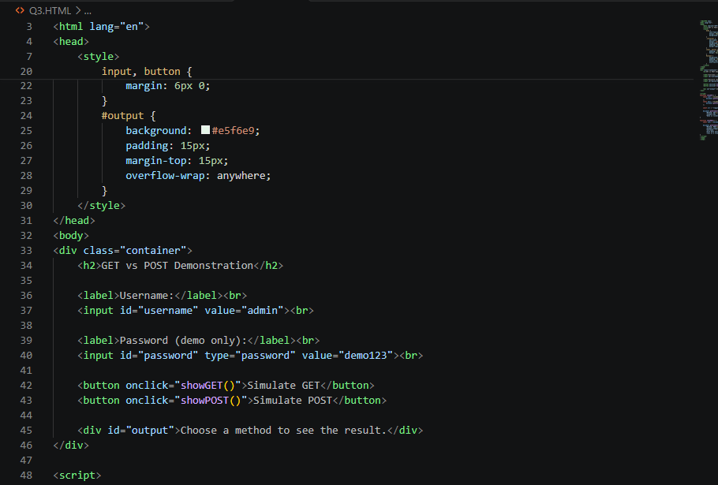
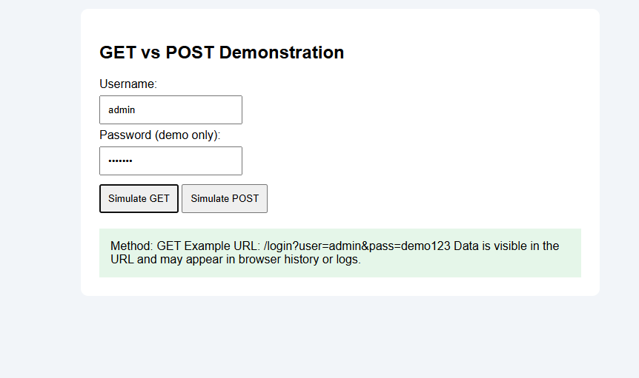

4. HTML Code Inspection
Original code from your assessment:
<!DOCTYPE html>
<html>
<head>
<title>Sample</title>
</head>
<body>
<h1>Welcome
<p>This is a paragraph
<img src="image.jpg">
</body>
</html>

Corrected code
Save this as sample.html.

<!DOCTYPE html>
<html lang="en">
<head>
<meta charset="UTF-8">
<title>Sample</title>
</head>
<body>
<h1>Welcome</h1>
<p>This is a paragraph.</p>
<img src="image.jpg" alt="A sample image">
</body>
</html>

Explanation
- </h1> closes the heading.
- </p> closes the paragraph.
- alt="A sample image" provides alternative text for accessibility.
- The <img> tag is a void element and does not require a closing tag.
- The image file must exist at the specified path to display the image.
Expected output:
BROWSER OUTPUT

Welcome
This is a paragraph.
The image appears here if image.jpg exists.
Screenshort:
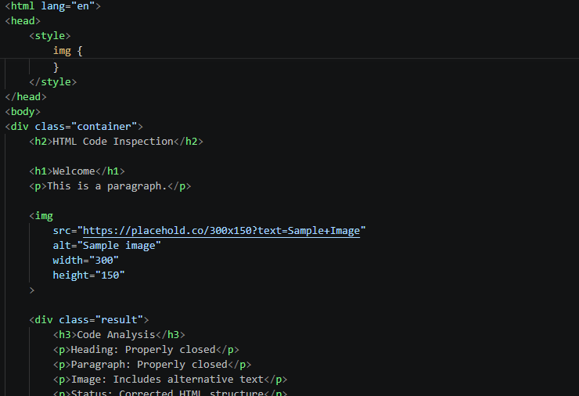
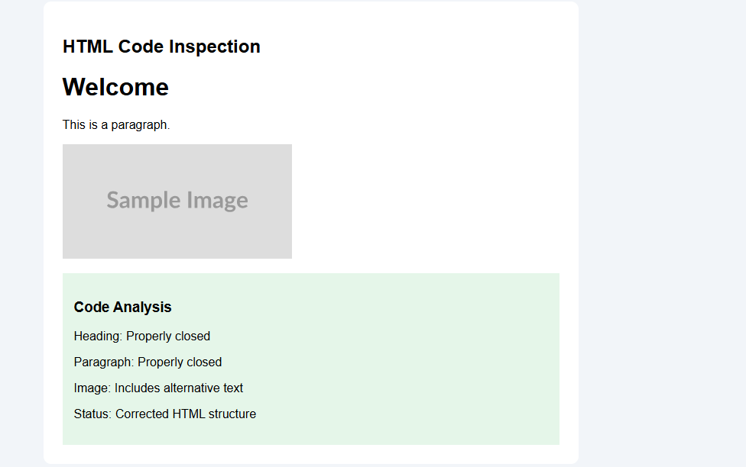

5. Browser–Server Communication Flow
The following six steps are given in your assessment PDF.
CSA43-CO1-MEDIUM - Data Interpretation.pdf

1
User enters URL
The user types a website address.

2
DNS lookup
The domain name is resolved to an IP address, often using a cache.

3
HTTP request
The browser sends a request to the server.

4
Server processes request
The server runs the required application logic.

5
Response returned
The server sends an HTTP status, headers, and body.

6
Browser renders page
The browser parses HTML, applies CSS, and runs JavaScript.

Where can delays occur?
- DNS lookup and network latency.
- Establishing a TCP/TLS connection.
- Slow server or database processing.
- Large images and other resources.
- Blocking CSS or JavaScript.

Performance optimizations
Use caching, a content delivery network (CDN), compressed responses, optimized images, efficient database queries, and minimized JavaScript and CSS files.
Screenshort:
